MCADAMS LADY GATOR BASKETBALL SCHEDULE
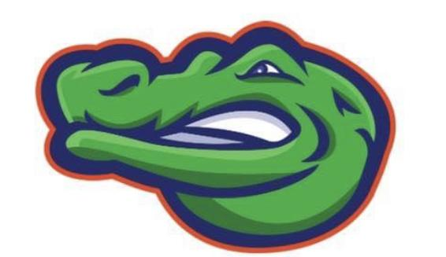
Tryouts may begin November 6th
DATE OPPONENT 8TH 7TH
Dec 7th Westbrook McAdams Westbrook
Dec 14th Kranz Kranz McAdams
Jan 11th Creekside Creekside McAdams
Jan 18th Friendswood McAdams Friendswood
Jan 25th Victory Lakes Victory Lakes McAdams
Feb 1st Bayside McAdams Bayside
Feb 8th Dickinson JH McAdams Dickinson JH
Feb 15th Brookside (ND) McAdams Brookside
District Tournament 2/21-23
7A- Space Center/ Space Center/Space Center
7B- Clear Lake/ Clear Lake/ Space Center
8A- LCI/ LCI/ LCI
8B- Clear Creek/ Clear Creek/ LCI

*B team plays at 5pm, A team plays immediately after

